Introduction:
I am interested in studying about the quality of inclusive practices (including children with special needs with typical peers) of Head Start preschool classrooms. Head Start mandates that 10% of the total children enrolled are reserved to serve children with special needs and their families.

I am interested in assessing Head Start classrooms using the Inclusive Classroom Profile (ICP) because the quality of classroom practices has an impact on student performance. Teacher’s knowledge, skills and experience of working with children with special need, the classroom environment, developmentally appropriate teaching practices, parent involvement and the support of the leadership with policies and practices of inclusion sets the tone for successful inclusion.

Head Start Act was passed in 1965 during the presidency of Lyndon B. Johnson as an answer to “war on poverty.” Head Start is the largest federally funded preschool program that offers free preschool education for families of low socio-economic background. The focus of the Head Start program is to give a Head Start for children in preschool so that they will be successful in grade school and beyond.

I believe that typical and atypical young children who attend preschool programs deserve a high quality learning experience. According to research children who attend high quality preschool programs are better readers, successful in grade school, attend college, make more money, less drop out and lead successful lives. According to economists investing in quality preschools makes financial sense as the return on investment is 1:7.

Even though Head Start has many mandates, assessing the quality of inclusive practices is not one of them. Children with special needs (atypical children) have many challenges to overcome in order to obtain a preschool education due to the limitations of their disability. By assessing the learning experience, I want to point out accommodations and modifications so that equitable learning experience can be offered to children with special needs in order for them to be successful in preschool and beyond. Even though an equal and fair preschool education is offered to all children, equality is not equity.

Research Topic:
Assessing the inclusive practices used by used by teachers of Head Start preschool classrooms to improve student performance
Research Questions:
- How have inclusive practices within Head Start classrooms impacted student performance?
- How do Head Start preschool teachers view the effectiveness of inclusive practices in their daily interactions with students?
Hypothesis:
High quality inclusive practices have an impact on student performances.
Null Hypothesis:
The quality of inclusive practices does not have an impact on student performances.

Dr. Last, Please note this page of information is for your reference only. I developed different questions, Hypotheses and Null Hypothesis.

LAB 1
Even though, I have elaborated on my dissertation topic and research interest,
The following information is related to the LAB 1 Assignment and the data:

- Develop at least two research questions related to your dissertation. These questions may be adjusted as you work through the course.
- Will boys with disabilities learn turn taking skills than girls? (This is a one tail question)
- Will boys and girls with disabilities learn turn taking skills? (This is a two tail question)

- Develop a hypothesis statement related to your data. This should include a null and alternative hypothesis. Also state your results in terms of whether you will be using one or two tailed test.
- Alternative Hypothesis - Children with disabilities in Head Start preschool classrooms will learn social skills.
- Null Hypothesis - Children with disabilities in Head Start preschool classrooms will not learn social skills (Per Dr. Last - Practices used in Head Start Preschool classrooms will not affect social skills)
- Since my hypothesis statement does not have a direction, I will be using a two tailed test.

- Indicate what your Independent Variable(s) [IV] and Dependent Variable [DV] are for these research questions.
- Independent Variable(s) [IV] – teaching social skills such as parallel play, Greeting, and Turn taking
- Dependent Variable [DV] – age, gender, disability

- Utilizing SPSS, develop a data set population of 100 items that includes the variables, the type of information required, and statistical specifics. Please see attached SPSS LAB 1
The information on this word document - pages 2 and 3

- Determine the descriptive statistics of this data set that relate to Central Tendency, ie. mean , median mode, etc. This should also include the variance and standard deviation.
The central tendencies were developed by SPSS. I have described each graph. Please see information in pages 3-8

- Display your data set utilizing two types of graphs. I developed histograms, bar graphs, and pie charts as outlined on pages 9-16

Frequencies

Statistics
 |  | GENDER | AGE | DISABILITY | Teach Social Skills
N | Valid | 101 | 101 | 101 | 101
 | Missing | 0 | 0 | 0 | 0
Mean |  | 1.50 | 4.07 | 2.43 | 1.96
Median |  | 1.00 | 4.00 | 2.00 | 2.00
Mode |  | 1 | 5 | 3 | 2
Std. Deviation |  | .502 | .828 | 1.003 | .774
Variance |  | .252 | .685 | 1.007 | .598
Skewness |  | .020 | -.131 | .026 | -.064
Std. Error of Skewness |  | .240 | .240 | .240 | .240
Kurtosis |  | -2.040 | -1.530 | -1.063 | -.987
Std. Error of Kurtosis |  | .476 | .476 | .476 | .476

Frequency Table
GENDER
 |  | Frequency | Percent | Valid Percent | Cumulative Percent
Valid | male | 51 | 50.5 | 50.5 | 50.5
 | female | 50 | 49.5 | 49.5 | 100.0
 | Total | 101 | 100.0 | 100.0

AGE
 |  | Frequency | Percent | Valid Percent | Cumulative Percent
Valid | 3 | 31 | 30.7 | 30.7 | 30.7
 | 4 | 32 | 31.7 | 31.7 | 62.4
 | 5 | 38 | 37.6 | 37.6 | 100.0
 | Total | 101 | 100.0 | 100.0

DISABILITY
 |  | Frequency | Percent | Valid Percent | Cumulative Percent
Valid | Autism | 22 | 21.8 | 21.8 | 21.8
 | Speech Impairment | 30 | 29.7 | 29.7 | 51.5
 | Down Syndrome | 33 | 32.7 | 32.7 | 84.2
 | Dev. Delay | 16 | 15.8 | 15.8 | 100.0
 | Total | 101 | 100.0 | 100.0

Teach Social Skills
 |  | Frequency | Percent | Valid Percent | Cumulative Percent
Valid | 0 | 1 | 1.0 | 1.0 | 1.0
 | Parallel Play | 29 | 28.7 | 28.7 | 29.7
 | Greeting | 44 | 43.6 | 43.6 | 73.3
 | Turn Taking | 27 | 26.7 | 26.7 | 100.0
 | Total | 101 | 100.0 | 100.0

Histogram

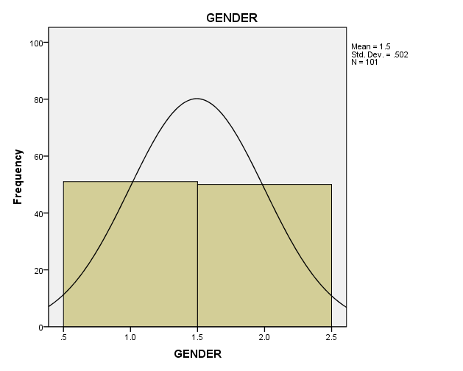
There are 50.5% boys and 49.5% girls with special needs. Total number of students is 101.
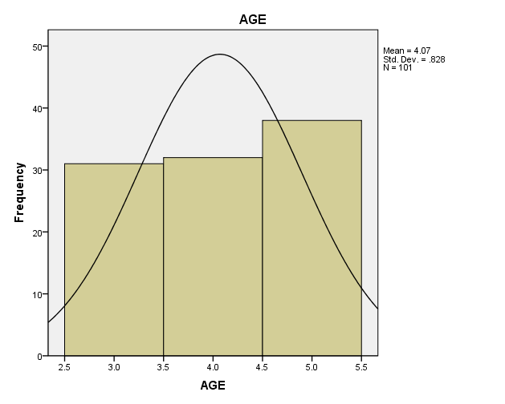

1.The above graph gives the following breakdown by age:
- 3 year old students 30.7%
- 4 year old students 31.7%
- 5 year old students 37.6%

- 5 year old are the highest.

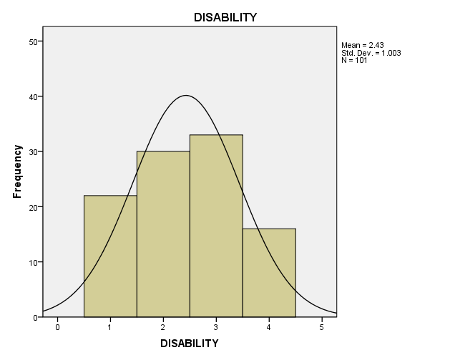

- The above graph represents 4 disabilities:
- There are 21.8% students with autism
- There are 29.7% students with Speech Impairment
- There are 32.7% students with Down Syndrome
- There are 15.8% students with Developmental Delay
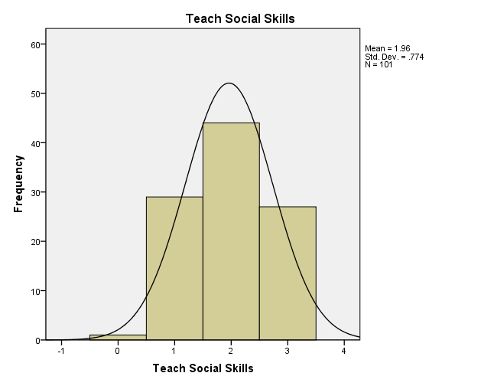

The above graph represents the social skills learned in the inclusive Head Start Preschool classroom.

Children did not learn any social skills 1%
Children learned parallel play skills 28.7%
Children learned greeting skills 43.6%
Children learned turn taking skills 43.6%

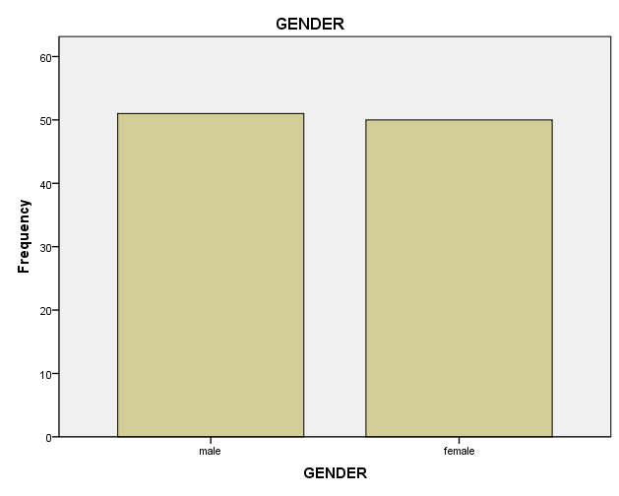

There are 50.5% boys and 49.5% girls with special needs. Total number of students is 101.

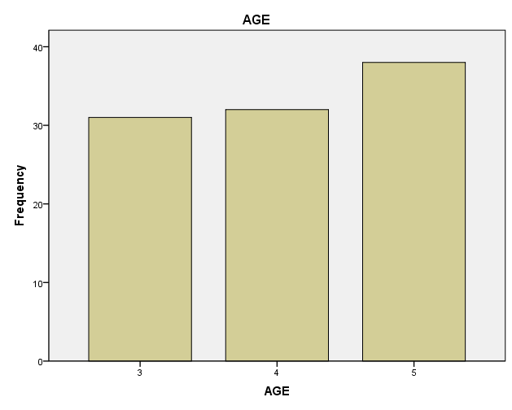

The above graph gives the following breakdown by age:
- 3 year old students 30.7%
- 4 year old students 31.7%
- 5 year old students 37.6%

5 year old are the highest.

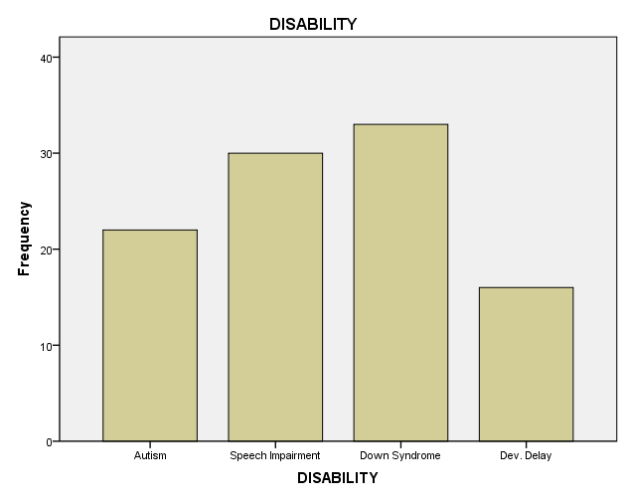

The above graph represents 4 disabilities:
There are 21.8% students with autism
There are 29.7% students with Speech Impairment
There are 32.7% students with Down Syndrome
There are 15.8% students with Developmental Delay

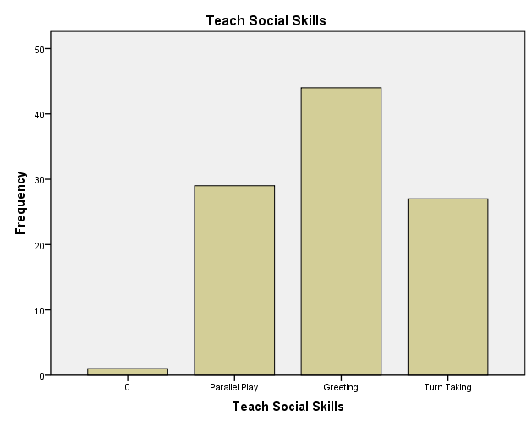

The above graph represents the social skills learned in the inclusive Head Start Preschool classroom.

Children did not learn any social skills 1%
Children learned parallel play skills 28.7%
Children learned greeting skills 43.6%
Children learned turn taking skills 43.6%

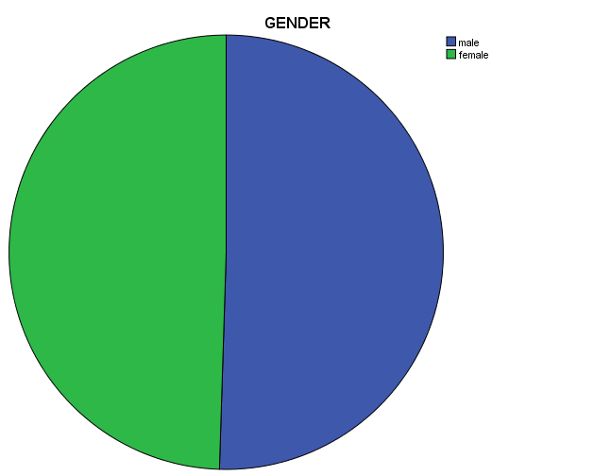

There are 50.5% boys and 49.5% girls with special needs. Total number of students is 101.

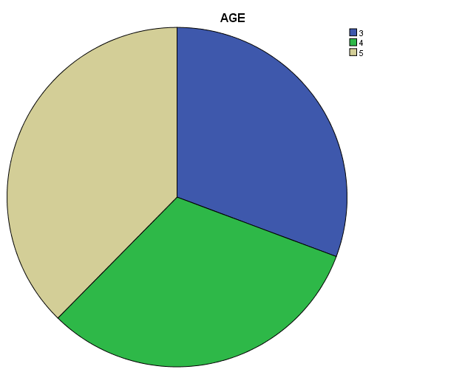
1.The above pie chart gives the following breakdown by age:
- 3 year old students 30.7%
- 4 year old students 31.7%
- 5 year old students 37.6%

- 5 year old are the highest.

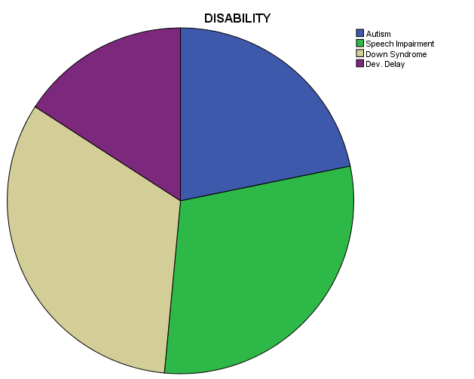

The above pie chart represents 4 disabilities:
There are 21.8% students with autism - BLUE
There are 29.7% students with Speech Impairment - GREEN
There are 32.7% students with Down Syndrome - GRAY
There are 15.8% students with Developmental Delay - PURPLE

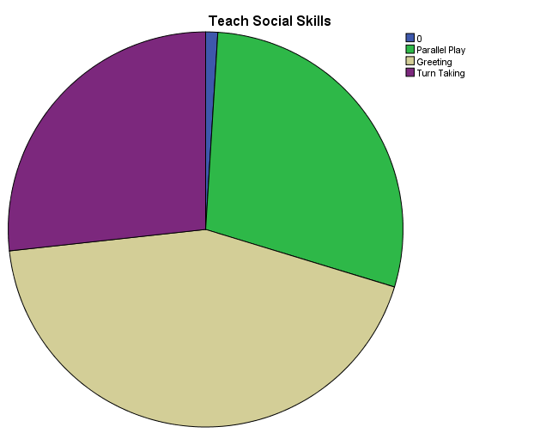

The above pie chart represents the social skills learned in the inclusive Head Start Preschool classroom.

Children did not learn any social skills 1%
Children learned parallel play skills 28.7%
Children learned greeting skills 43.6%
Children learned turn taking skills 43.6%

