Ifthika “Shine” Nissar
EDUC 707
Dr. Barry Last
LAB 5

You are to do the following for your final Lab assignment.

- Make any revisions as necessary for your research questions and hypotheses
a. Research question:
Will there be a relationship between preschool children with different levels of autism and social skills learned in Head Start preschool classrooms?
b. Alternative Hypothesis – Preschool children with different levels of autism will learn social skills in Head Start preschool classrooms.
c. Null Hypothesis –
Preschool children with different levels of autism have no relationship to learning social skills in Head Start Preschool classrooms.
d. I.V. – Teaching social skills
D.V. – Students with autism
- Take your sample data set an conduct the following statistical tests:
Chi Square
  - Follow the example that I have used with the “Bullying Data Set – N/A
  - First utilize the Cross Tabs Approach to examine the data checking off the Chi Square
  - Go to Non Parametric Test Analysis and use the Independent Samples

Case Processing Summary
 | Cases
 | Valid |  | Missing |  | Total
 | N | Percent | N | Percent | N | Percent
Teach Social Skills * DISABILITY | 101 | 100.0% | 0 | .0% | 101 | 100.0%

Teach Social Skills * DISABILITY Crosstabulation
 |  |  | DISABILITY
 |  |  | Autism | Speech Impairment | Down Syndrome
Teach Social Skills | 0 | Count | 1 | 0 | 0
 |  | Expected Count | .2 | .3 | .3
 | Parallel Play | Count | 5 | 11 | 8
 |  | Expected Count | 6.3 | 8.6 | 9.5
 | Greeting | Count | 13 | 10 | 12
 |  | Expected Count | 9.6 | 13.1 | 14.4
 | Turn Taking | Count | 3 | 9 | 13
 |  | Expected Count | 5.9 | 8.0 | 8.8
Total |  | Count | 22 | 30 | 33
 |  | Expected Count | 22.0 | 30.0 | 33.0

Teach Social Skills * DISABILITY Crosstabulation
 |  |  | DISABILITY | Total
 |  |  | Dev. Delay
Teach Social Skills | 0 | Count | 0 | 1
 |  | Expected Count | .2 | 1.0
 | Parallel Play | Count | 5 | 29
 |  | Expected Count | 4.6 | 29.0
 | Greeting | Count | 9 | 44
 |  | Expected Count | 7.0 | 44.0
 | Turn Taking | Count | 2 | 27
 |  | Expected Count | 4.3 | 27.0
Total |  | Count | 16 | 101
 |  | Expected Count | 16.0 | 101.0

Chi-Square Tests
 | Value | df | Asymp. Sig. (2-sided)
Pearson Chi-Square | 12.437ª | 9 | .190
Likelihood Ratio | 12.142 | 9 | .205
Linear-by-Linear Association | .367 | 1 | .545
N of Valid Cases | 101
6 cells (37.5%) have expected count less than 5. The minimum expected count is .16.

Analysis of the graphs…
- The Case Processing Summary has 100% validity.

- The Teach Social Skills * DISABILITY Crosstabulation, there is a discrepancy in social skills in the three categories that I am studying- greeting, parallel play and social skills.

- Chi-Square Tests - 6 cells (37.5%) have expected count less than 5. The minimum expected count is .16. Since this is a positive number, I am rejecting my null hypothesis. Therefore, my hypothesis stands for this tabulation.

2. Continued…
d. At the top of the second window select three dependent areas to test
1. D.V. – Students with autism
2. D.V – Ethnicity
c. D.V - Gender

e. For the groups, use your independent variable
I.V. – Teaching social skills

f. Run the test and analyze the data
The significance level is .05
- For ethnicity null hypothesis was retained with a sig. of .420 in the One sample Chi-square test
- For gender the null hypothesis was retained with a sig. of 1,000 in the One sample Binomial Test with a 0.5 probability for male and female students with autism
- Null Hypothesis was rejected in the areas of teaching language skills, teaching math skills, teaching reading skills, teaching self-help skills and student performance of equal probabilities due to the sig. being .000
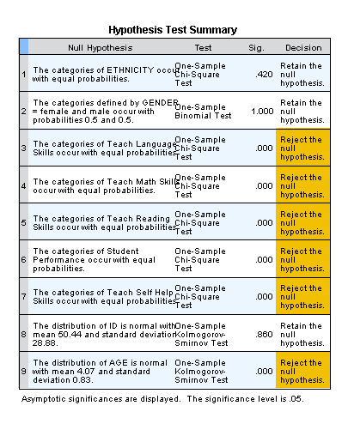

- Of the six statistical analysis that we have used in this course, ie. Frequency, “t” tests, ANOVA, Correlation, Linear Regression, and Chi Square; you are to do the following:
  - Select the three analyses that will provide you the best information for your dissertation
b. Show the results of the three analysis – My lab assignments 1, 2 and 3
c. Explain why each of the analyses is the most appropriate for your dissertation

3. a, b, and c)
i. Frequency Statistical Analysis – In statistics frequency of an event (i) or the number (n) of times the event occurrence of a study. There are relative frequency and cumulative frequency. Frequency Statistical Analysis is represented by Histograms. I like this visual representation of the Histograms.

Frequency Statistical Analysis will be appropriate for my dissertation to discuss the tables and get a visual representation of my variables.

LAB 1
- Determine the descriptive statistics of this data set that relate to Central Tendency, ie. mean , median mode, etc. This should also include the variance and standard deviation.
The central tendencies were developed by SPSS. I have described each graph. Please see information in pages 3-8

- Display your data set utilizing two types of graphs. I developed histograms and bar graphs as posted below.

Frequencies (LAB 1)

Statistics
 |  | GENDER | AGE | DISABILITY | Teach Social Skills
N | Valid | 101 | 101 | 101 | 101
 | Missing | 0 | 0 | 0 | 0
Mean |  | 1.50 | 4.07 | 2.43 | 1.96
Median |  | 1.00 | 4.00 | 2.00 | 2.00
Mode |  | 1 | 5 | 3 | 2
Std. Deviation |  | .502 | .828 | 1.003 | .774
Variance |  | .252 | .685 | 1.007 | .598
Skewness |  | .020 | -.131 | .026 | -.064
Std. Error of Skewness |  | .240 | .240 | .240 | .240
Kurtosis |  | -2.040 | -1.530 | -1.063 | -.987
Std. Error of Kurtosis |  | .476 | .476 | .476 | .476

Frequency Table
GENDER
 |  | Frequency | Percent | Valid Percent | Cumulative Percent
Valid | male | 51 | 50.5 | 50.5 | 50.5
 | female | 50 | 49.5 | 49.5 | 100.0
 | Total | 101 | 100.0 | 100.0

AGE
 |  | Frequency | Percent | Valid Percent | Cumulative Percent
Valid | 3 | 31 | 30.7 | 30.7 | 30.7
 | 4 | 32 | 31.7 | 31.7 | 62.4
 | 5 | 38 | 37.6 | 37.6 | 100.0
 | Total | 101 | 100.0 | 100.0

DISABILITY
 |  | Frequency | Percent | Valid Percent | Cumulative Percent
Valid | Autism | 22 | 21.8 | 21.8 | 21.8
 | Speech Impairment | 30 | 29.7 | 29.7 | 51.5
 | Down Syndrome | 33 | 32.7 | 32.7 | 84.2
 | Dev. Delay | 16 | 15.8 | 15.8 | 100.0
 | Total | 101 | 100.0 | 100.0

Teach Social Skills
 |  | Frequency | Percent | Valid Percent | Cumulative Percent
Valid | 0 | 1 | 1.0 | 1.0 | 1.0
 | Parallel Play | 29 | 28.7 | 28.7 | 29.7
 | Greeting | 44 | 43.6 | 43.6 | 73.3
 | Turn Taking | 27 | 26.7 | 26.7 | 100.0
 | Total | 101 | 100.0 | 100.0
Histogram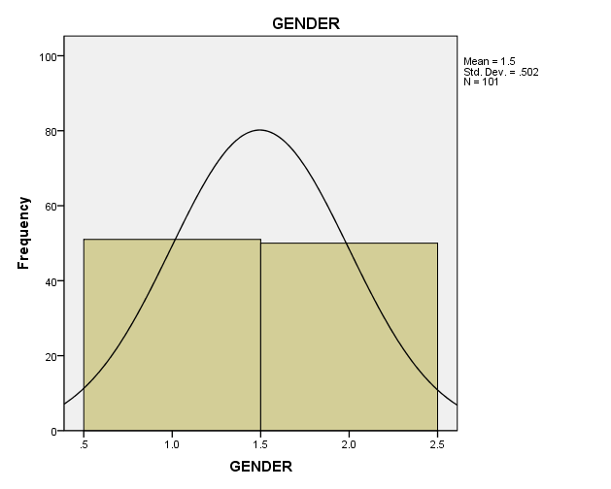There are 50.5% boys and 49.5% girls with special needs. Total number of students is 101. 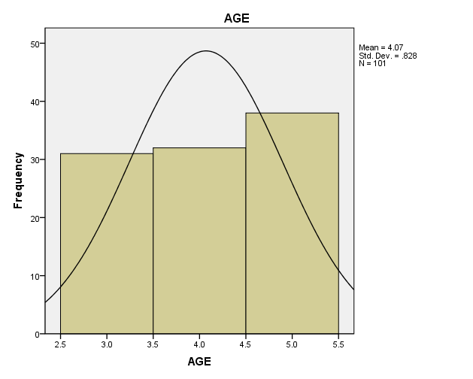
1.The above graph gives the following breakdown by age:
- 3 year old students 30.7%
- 4 year old students 31.7%
- 5 year old students 37.6%

- 5 year old are the highest.
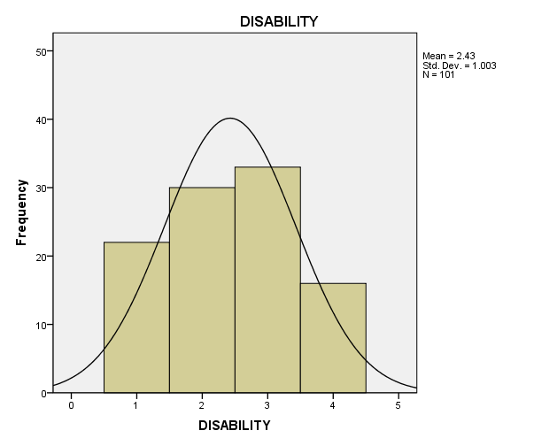
- The above graph represents 4 disabilities:
- There are 21.8% students with autism
- There are 29.7% students with Speech Impairment
- There are 32.7% students with Down Syndrome
- There are 15.8% students with Developmental Delay
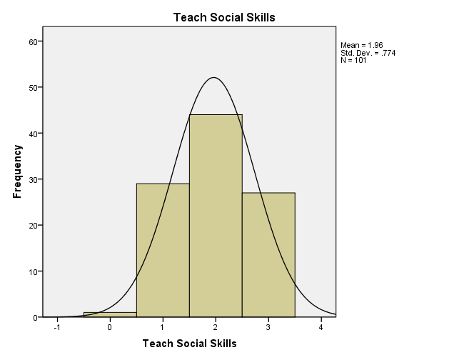

The above graph represents the social skills learned in the inclusive Head Start Preschool classroom.
Children did not learn any social skills 1%
Children learned parallel play skills 28.7%
Children learned greeting skills 43.6%
Children learned turn taking skills 43.6%

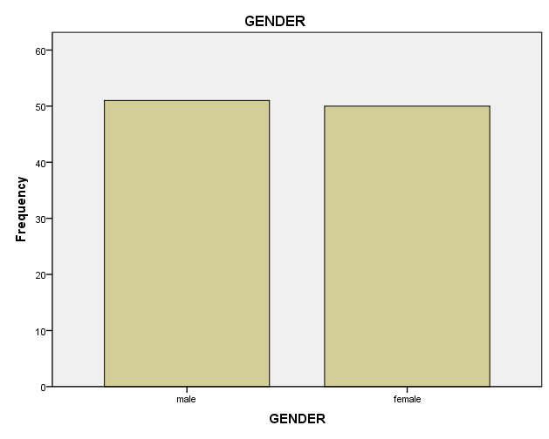

There are 50.5% boys and 49.5% girls with special needs. Total number of students is 101.
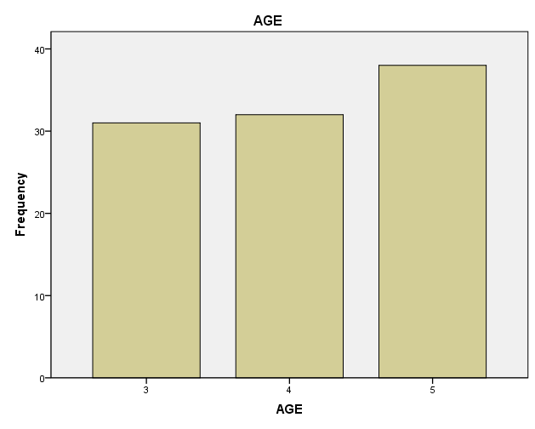
The above graph gives the following breakdown by age:
- 3 year old students 30.7%
- 4 year old students 31.7%
- 5 year old students 37.6%
- 5 year old are the highest.
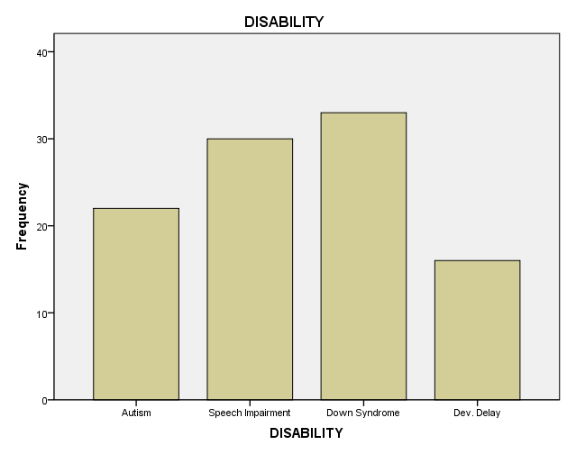

The above graph represents 4 disabilities:
There are 21.8% students with autism
There are 29.7% students with Speech Impairment
There are 32.7% students with Down Syndrome
There are 15.8% students with Developmental Delay

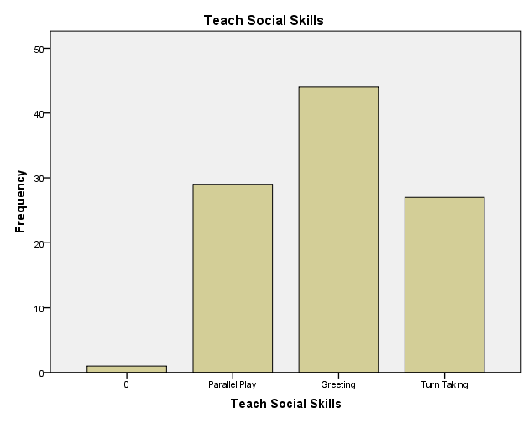

The above graph represents the social skills learned in the inclusive Head Start Preschool classroom.

Children did not learn any social skills 1%
Children learned parallel play skills 28.7%
Children learned greeting skills 43.6%
Children learned turn taking skills 43.6%

- t-test Statistical Analysis LAB 2
t-test is widely used to compare the means between two different samples in statistical analysis.
There is one-directional t-test and two-directional t-test.
One-directional: rejecting the null hypothesis when it is true
Two-directional: accepting the null hypothesis when it is false
When a hypothesis statement has a direction, we use a one tailed t-test and when hypothesis statement does not have a statement we use a two tailed t-test.
Example of a hypothesis to use a two-tailed test
Preschool children with different levels of autism have no relationship to learning social skills in Head start preschool classrooms.
t-test can be used to determine if two sets of data are significantly different from each other.
t-test is most commonly applied when we follow a follow a normal distribution.
By using the t-test for data analysis, we can reject the null hypothesis (which means the alternative hypothesis will be accepted).

t-test Statistical Analysis will be appropriate for my dissertation to analyze my data and reject the null hypothesis.

One-Sample Statistics
 | N | Mean | Std. Deviation | Std. Error Mean
Autism | 39 | 1.8974 | .78790 | .12616
Teach Social Skills | 39 | 1.87 | .801 | .128

One-Sample Test
 | Test Value = 0
 | t | df | Sig. (2-tailed) | Mean Difference | 95% Confidence Interval of the Difference
 |  |  |  |  | Lower | Upper
Autism | 15.039 | 38 | .000 | 1.89744 | 1.6420 | 2.1528
Teach Social Skills | 14.600 | 38 | .000 | 1.872 | 1.61 | 2.13

- Analyze the “t” test information and determine whether the data confirms or rejects the null hypothesis
_{Degree of Freedom is 38}
_{Probability level 0.05}
Critical Value (for two tailed) = +/- 2.02439416
- Write up a summary of your results
_{Decision Rule}: If it is less than 2.024 or more than 2.0243, reject the null hypothesis.

Autism t = 15.039
Teach Social t = 14.600
Reject the Null Hypothesis

iii. ANOVA - LAB 2
Analysis of variance is used to analyze the differences between group means and among the means of the groups.
In order to use ANOVA the number of sample data has to be significant.
Usually ANOVA is used to test the means of three or more groups at once.
(If P value is less than 95% (or .05), you reject the null hypothesis
If P value is more than 95%(or .05), you accept the null hypothesis)
ANOVA provides a statistical test of whether or not the means of several groups are equal, and therefore generalizes the t-test to more than two groups. Doing multiple two-sample t-tests would result in an increased chance of committing a type I error. For this reason, ANOVAs are useful in comparing (testing) three or more means (groups or variables) for statistical significance.

- Conduct an Independent Sample “t” Test
  - Select a Test and Grouping Variable
The Test is ANOVA
Grouping Variables on Dependent List (Autism and Teaching Social Skills) and the Factor is Ethnicity
b. Determine the “F” value for your sample population
The “F” value are 1.103 and .545
  - Determine whether the null hypothesis has been reject and write at least two statements
For my type of data with a small F value of 1.103 and .545 ANOVA will not work. Therefore, can’t tell if the null hypothesis will be rejected.

- Taking your sample data set, conduct a One Way Analysis of Variance (ANOVA) test with SPSS
  - Select the dependent and factor (grouping variables)
The Test is ANOVA
Grouping Variables on Dependent List (Autism and Teaching Social Skills) and the Factor is Ethnicity

  - Select the descriptive area within ANOVA chart
The descriptive are on the ANOVA chart is between 30 and 30 is 1.84
  - Also run the Scheffe Post Hoc Test
  - Analyze the tables
Grouping Variables are Autism and Teaching Social Skills.
ANOVA will not work for my sample as my sample is very small.
The degree of freedom for Autism is 38 and Teaching Social Skills is 38.

  - Examine the “F” results and the significance using the Scheffe Test
The “F” values are 1.103 and .545
  - Write up a summary of your results
For my type of data with a small F value of 1.103 and .545 ANOVA will not work.
ANOVA
 |  | Sum of Squares | df | Mean Square | F | Sig.
Autism | Between Groups | 2.709 | 4 | .677 | 1.103 | .371
 | Within Groups | 20.881 | 34 | .614
 | Total | 23.590 | 38
Teach Social Skills | Between Groups | 1.468 | 4 | .367 | .545 | .704
 | Within Groups | 22.891 | 34 | .673
 | Total | 24.359 | 38

Analysis Of variance Analysis (ANOVA) will be appropriate for my dissertation to analyze between group mean and among the mean of groups. I am hoping to have a larger sample size so that ANOVA will be effective.

